Batch: B1 Roll No.: 1711072

Experiment / assignment / tutorial No.03

Grade: AA / AB / BB / BC / CC / CD /DD

Signature of the Staff In-charge with date

Title: PC assembling

AIM: To study all basic components of PC and their assembling
______________________________________________________________________
Expected OUTCOME of Experiment:

CO 2: To assemble, administrate and upgrade the system.

____________________________________________________________________
Books/ Journals/ Websites referred:
- IBM- PC BY Govindrajalu, THM
_____________________________________________________________________
Pre Lab/ Prior Concepts:
Building a computer can be a very rewarding experience. This is a very viable option these days and can bring many benefits; you can learn a lot about computer hardware by building one, you get a totally personalized computer, you can choose better components and you may be able to save some money. Additionally, if you are the sort of person who wants to understand how things work, if you take broken stuff apart just to see how it all fits together, if you have a drawer somewhere full of “parts” you think may come in handy someday, then you just may be in the right place.

- Choosing the Parts

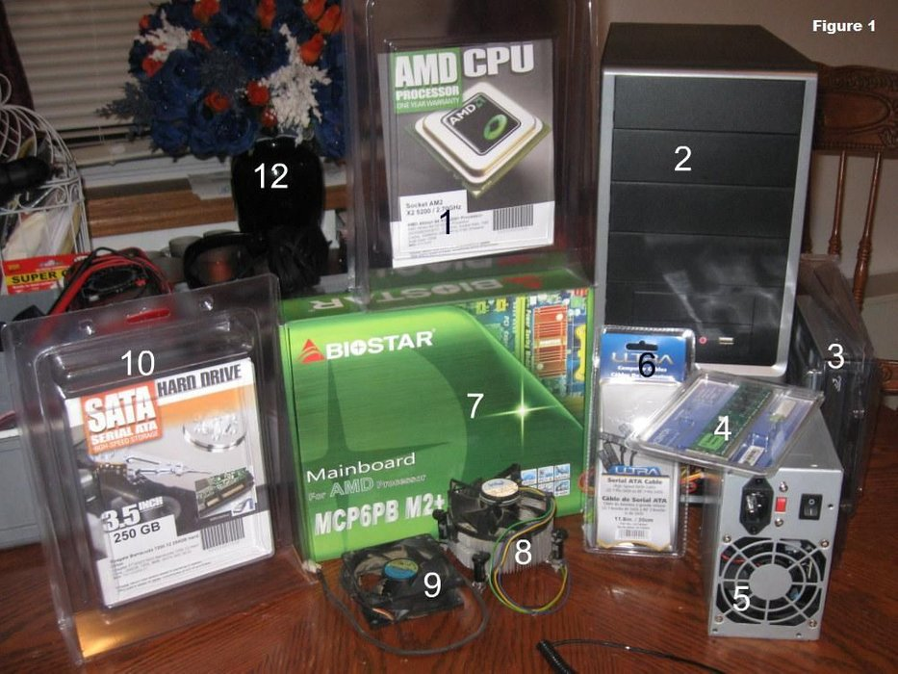
1. Processor (CPU)
2. Computer Case
3. Optical Drive (DVD RW and SATA capable)
4. Memory (RAM)
5. Power Supply
6. SATA Cables
7. Motherboard (SATA Capable)
8. Processor Fan
9. Case Fan
10. Hard Drive (SATA Capable)

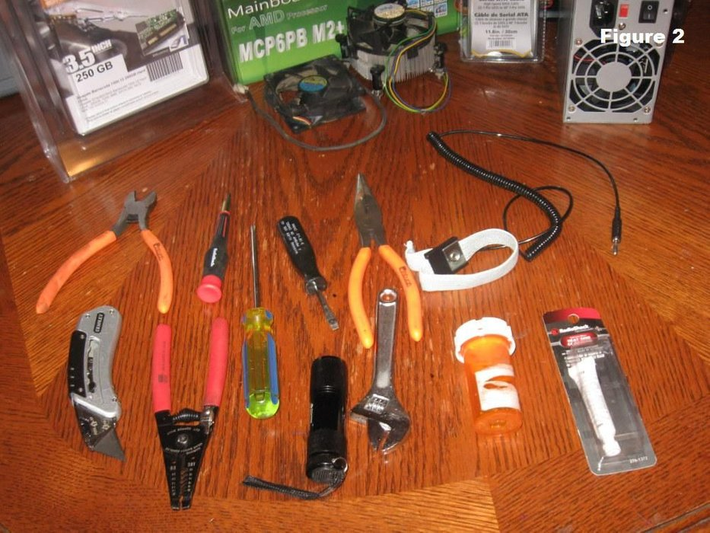
- Screwdriver (for slotted and Phillips head screws)
- Wire cutters and strippers
- Needle-nosed pliers
- Utility knife
- Small flashlight
- Adjustable wrench
- Small container to hold screws
- Heat sink compound
- Grounding Strap

- Open the Case
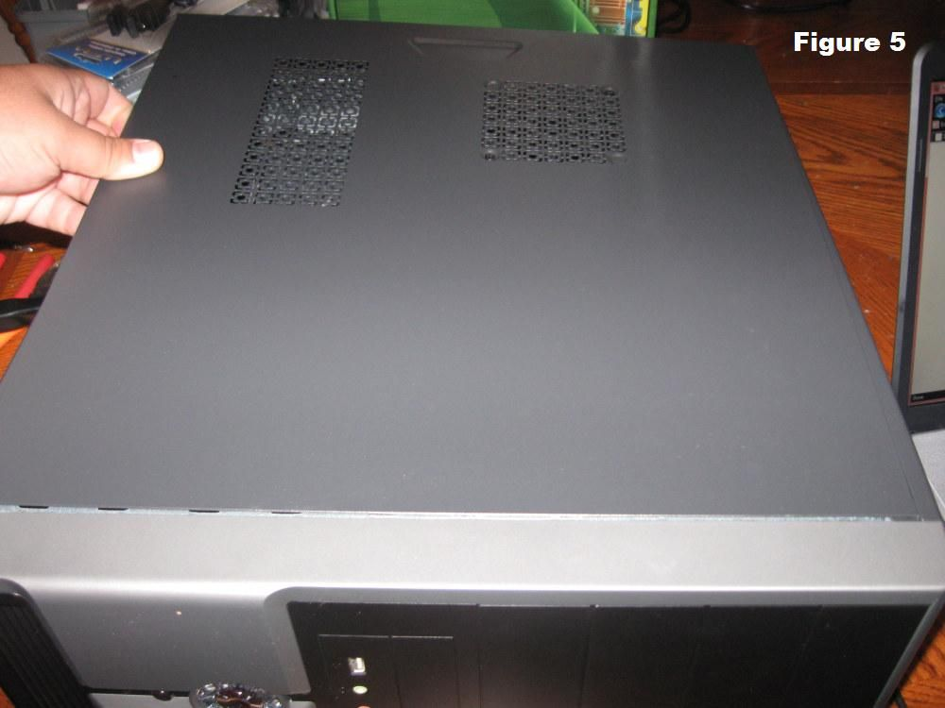
- Install the Power Supply
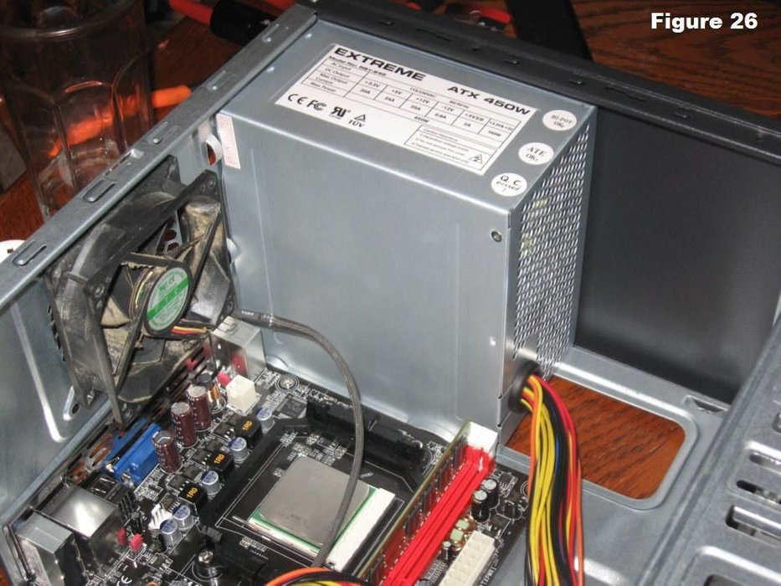

- Attach the Components to the Motherboard and Install the Motherboard
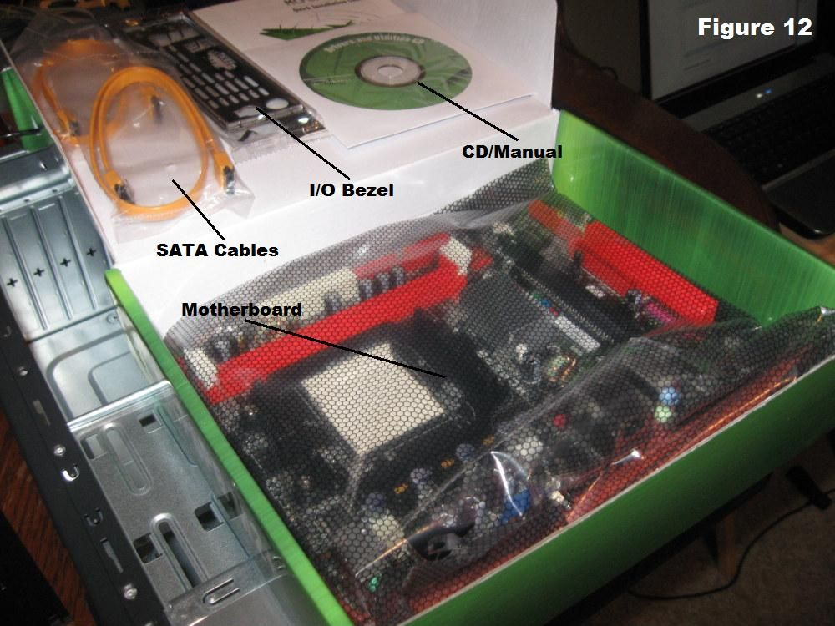

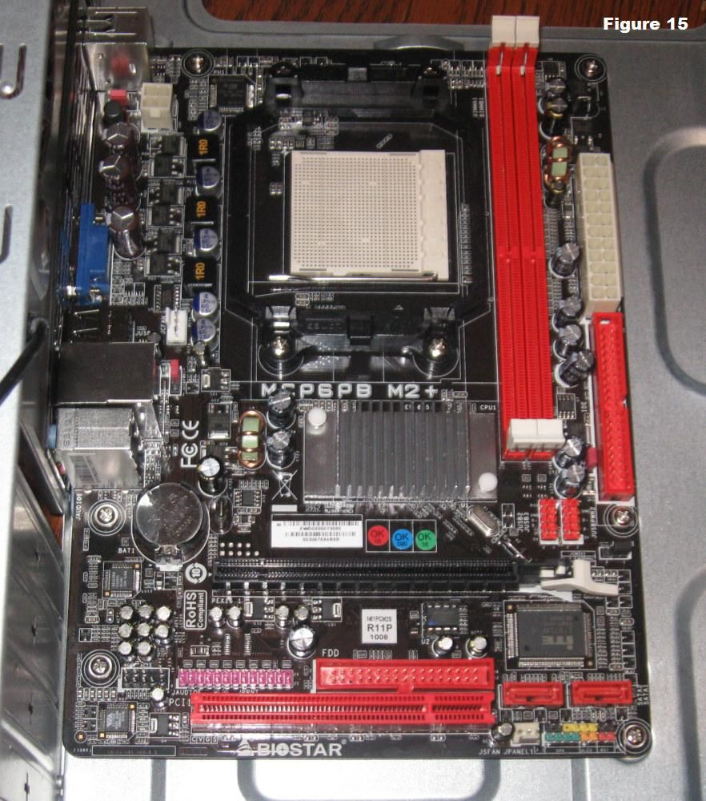

5. Install a CPU and a Heat Sink/Fan Assembly

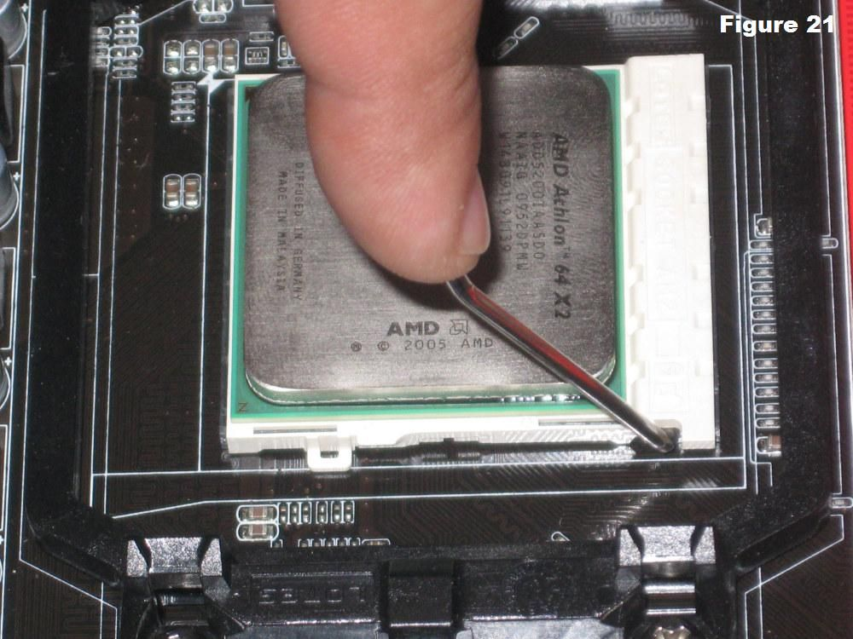
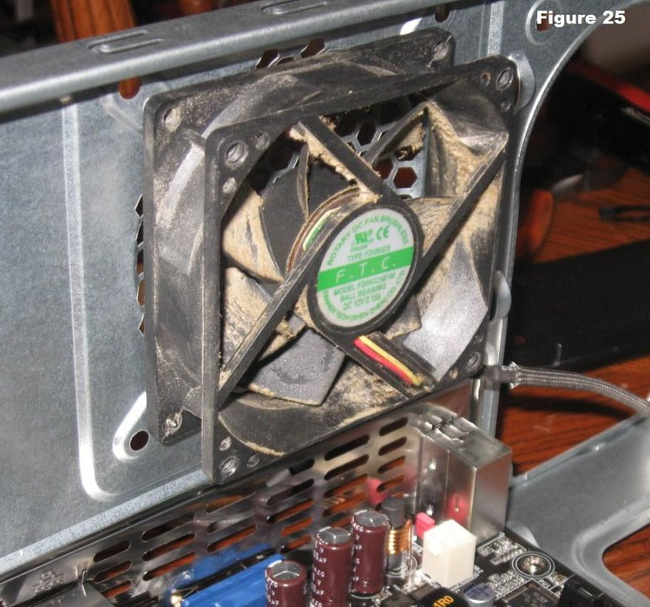
6. Install Drives in External Bays
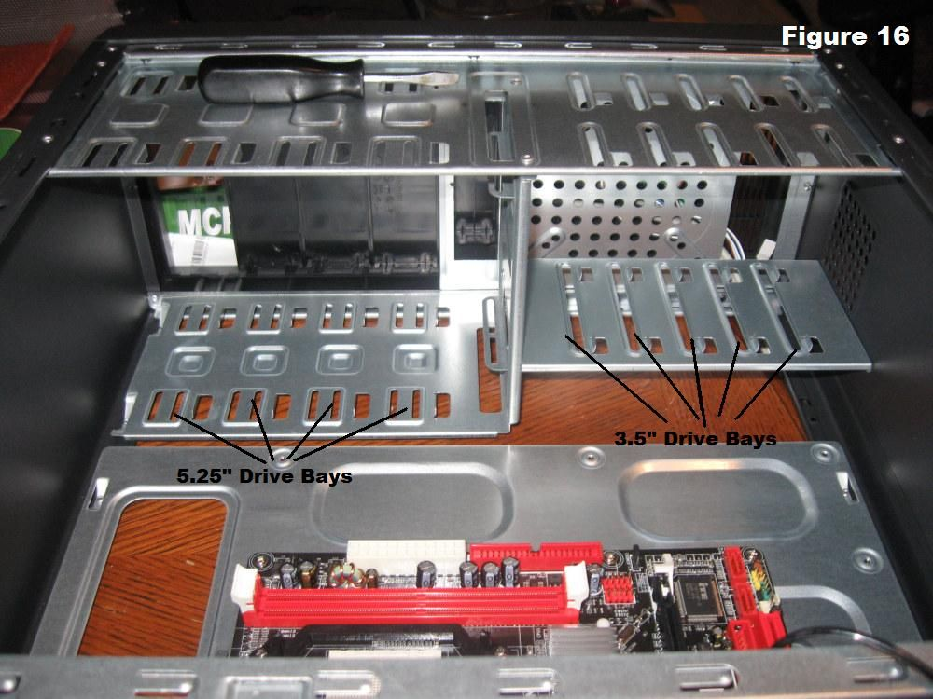

- Install RAM
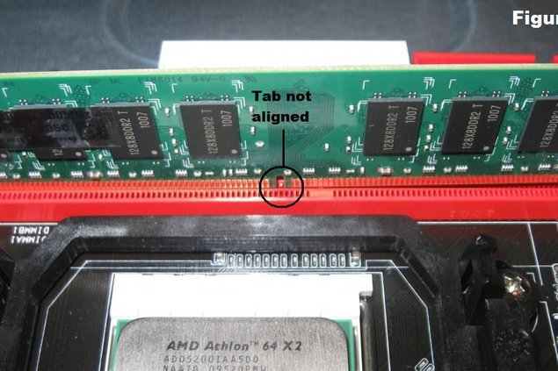
- Connect the Power Cables

- Connect the Data Cables
PATA Data Cables and SATA Data Cables

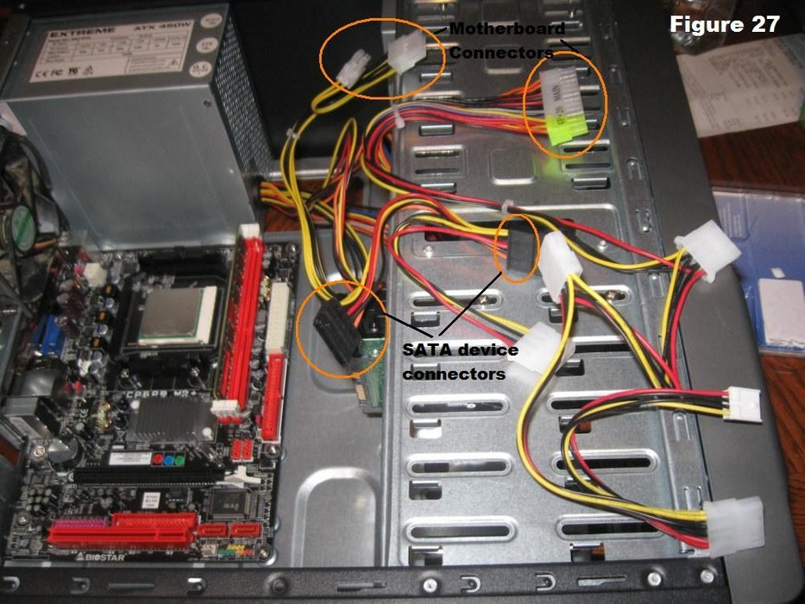

- Complete Physical Installation

Reattach the Side Panels to the Case and connect External Cables to the PC

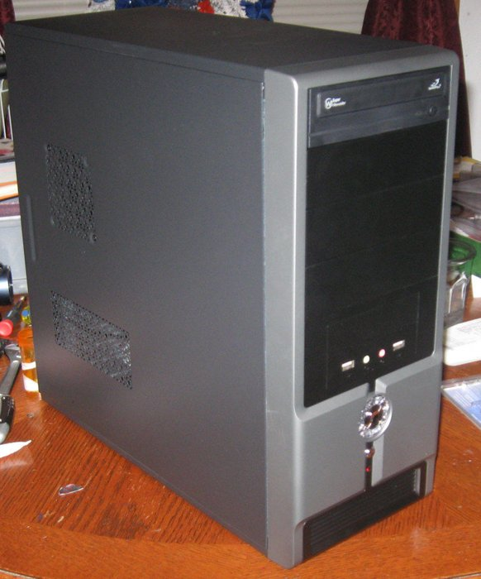

- Boot Computer for the First Time

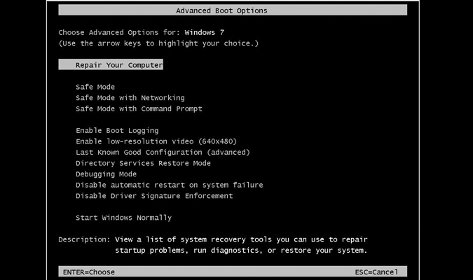

Conclusion: The CPU was disassembled and assembled successfully.

Post Lab questions

1) What is burn-in test? When to do burn-in test?
2) How to load default setting of CMOS?

Ans 1. In computer testing, a burn-in test is a type of test where a computer, device or component is run for an extended length of time in order to identify any potential problems.
It aims to reveal any problems or defects within a system by operating it in the most rigorous, extreme or extended working conditions.

Ans 2.
- Enter CMOS setup.
- In CMOS setup, look for an option to reset the CMOS values to the default setting or an option to load the fail-safe defaults. With many CMOS setup screens, there will be a function key to do this. For example, the F5, F6, F9, F11, or F12 key, as shown in the picture, may be set up as a shortcut to load the default settings. Other setups may list an option that you can arrow over to using the arrow keys and pressing Enter.
- When found and selected, you'll likely be asked if you're sure you want to load the defaults. Press Y for yes or arrow to the yes option.
- Once the default values have been set, make sure to Save and Exit and not just exit.

Date: 08/02/2019 Signature of faculty in-charge

